Installation Guide of Tool for Analysis of Interim Datasets ESS11

Requirements and Implementation

*Roberto Briceno-Rosas¹, Joost Kappelhof², May Doušak³, Rebekka Kluge¹, Paulette Flore², Sander Steijn², and Jannine van de Maat²*

*¹* GESIS – Leibniz Institute for the Social Sciences

*²* SCP – The Netherlands Institute for Social Research

*³*University of Ljubljana

Introduction 1

General description of the tool for Analysis of Interim Dataset 2

Requirements 2

Installation procedure 3

Implementation 3

Troubleshooting & FAQ 4

# Introduction

In ESS Round 10, National Teams of participating countries are expected to analyse an interim dataset from the main questionnaire to check for data quality and detect interviewer-related data quality issues arising during the interviewing process with the support of the CST. The objective of this measure is – in case of systematic interviewer-related problems during the interview process – to detect these problems early and if possible intervene and correct them while the data collection process is still on-going (as defined in the ESS Specification, see below).

*“After approximately one third of the planned interviews have been completed, the Survey Agency is required to provide an interim data file to the NC for initial checking of interview quality. The NC will be provided with syntax by the CST and asked to use the syntax to flag potential problematic interviews and/or interviewers and discuss the results with the CST. This information should be used in discussion with the Survey Agency with respect to ongoing quality control procedures. Note that the interim data file should contain a numeric interviewer identifier to enable the Survey Agency to identify any interviewers flagged.“* [1]

As mentioned in the specifications, the CST has developed a tool for the analysis of the ESS interim datasets to facilitate this process. This paper informs about the requirements for using the tool and how it should be installed and implemented.

# General description of the Tool for Analysis of Interim Dataset

The tool allows for standardised analysis of the ESS interim datasets in a user-friendly manner. It takes the ESS interim dataset, runs a predefined syntax over data, and presents the results in textual and graphical format. As shown in the figure below, the tool has three key components which are embedded in a Windows application: (a) the ESS interim datasets, (b) the syntax with the code for the analysis, (c) a PDF report with the results. This allows keeping the requirements and effort for the National Team to a minimum. The Windows application provides a front-end that allows users to run the tool in an intuitive manner. The syntax for the analysis has been written in R, whichis a free software environment for statistical computing and graphics, and National Teams can adapt it if they wish to. The software also allows for more transparency about the indicators and for easier collaboration.

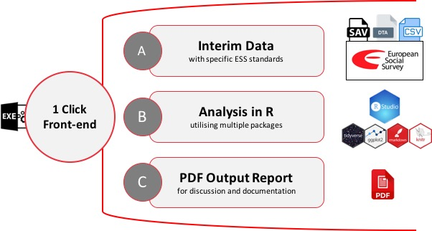

# Requirements

**Data requirements**

* *Main Dataset*: Interim Dataset from the Main Questionnaire with structure as specified in ESS10 Data Protocol, including the specified variables names and formats (see ESS10 2020 Data Protocol in myESS[2]). Please note that the structure of the dataset is fundamental for the tool to work. We recommend setting up the dataset to the specified format from the start of fieldwork. The amount of time required to convert the interim dataset to specified format at a later stage can be quite substantial and in turn will be a net loss in the effectiveness of implementing this measure in a timely manner.
* *Interviewer Dataset*: A dataset with the case identification number (IDNO) and its respective interviewer identification number (ITNUM).
* Both datasets need to be on one of following formats: SAV, DTA, SAS, or CSV.

**System requirements**

* Windows 7 or newer
* .NET 4 or newer
* 2 GB free disk space

# Installation procedure

The tool resides in its folder and works without installation.

1. User should simply unzip the downloaded file anywhere on disk.
2. A new folder called “ToolVx” will be created on destination (x for version of the tool).

Depending on the speed of computer, unzipping might take a few minutes.

# Implementation

e

c

|  |  |
| --- | --- |
| a) Open the newly created folder “ToolVx” and run “Tool” file with the ESS logo (EXE file): | Graphical user interface  Description automatically generated with low confidence  aa  a |
| b) The application opens. The interface of the tool is shown on the right:  c) Please provide the *Main dataset* and the *Interviewer dataset* files, which should comply with the requirements previously mentioned. Both datasets need to be on the same file format (SAV, DTA, SAS, or CSV files)  d) Please choose output folder where the report PDF will be saved.  e) Click “Generate”. The tool will indicate that is generating the report below.  *Depending on your computer, report generation might take anywhere from 5 to 30 minutes. In some cases, it might take up to an hour.*  f) Retrieve the PDF Report from the designated folder. Please take the time to review the report and discuss any issues with the survey agency and the CST. Share the report with your Country Contact.  g) The annex folder within the tool will contain CSV files with relevant indicators that might help investigate issues in more detail. See Tool_files\Annex within folder of the tool. | Graphical user interface, text, application, email  Description automatically generated  d  c |
|  |

# Troubleshooting & FAQ

**Windows Smart Screen when first running the tool**

First time you run it, Windows Smart Screen protection might pop up: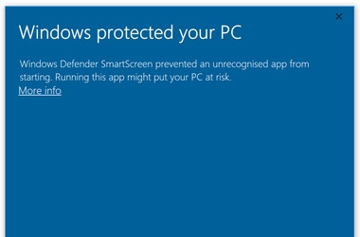Should this happen, please click “More Info” and press the button “Run Anyway”:

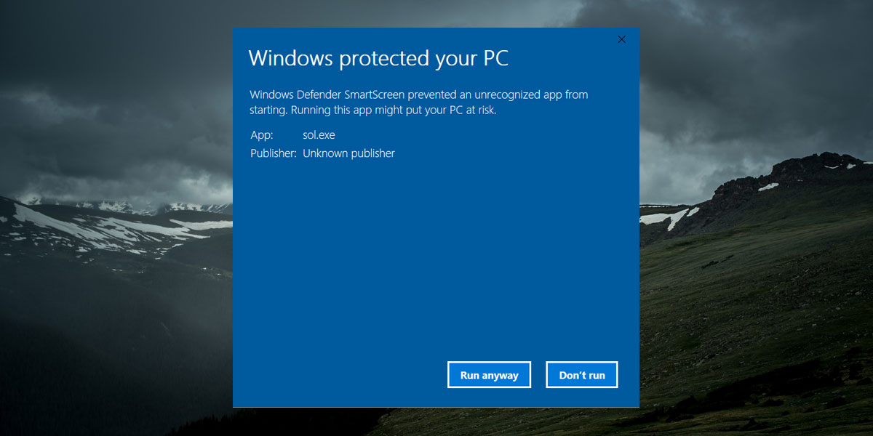

**Running the Tool in another operating systems like MacOS and Linux**

Currently, the CST only provide support for running the tool in Windows. However, it is possible to run the code and produce the PDF in MacOS and Linux. Some basic knowledge in R is required. For this purpose, users can extract the syntax (RMD code) and related files in order to run the code in their computers using R. Please note that users will need to install the necessary software (R, R Studio, and MikTex) and assigned the respective path for the datasets manually.

**Who to contact in case of problem**

In case of other problems or questions, please contact the CST via myESS (Team Forum/Topic/Desirable Interviewer Behaviour) or your Country Contact.

***Please be advised that further updates (e.g., regarding FAQ and troubleshooting) might be provided based on the initial experiences. Further guidance regarding the interpretation of the analysis results will be provided if required.***

1. More information available in the *Round 10 Survey Specification for ESS ERIC Member, Observer and Guest Countries* (<https://www.europeansocialsurvey.org/docs/round10/methods/ESS10_project_specification.pdf>).
2. Please note that the final Data Protocol should be used. Alerts with changes to the current version are planned and will inform NCs of any changes to the current Data Protocol. Find the Data Protocol at: <https://ess.nsd.no/portal/intranet/detail/repository/collaboration/sites/intranet/web%20contents/essweb/data_protocol>